**What is the SDMX Istat Toolkit?**

The SDMX Istat Toolkit (SDMX-IT) is a set of pick-and-choose, free and open-source, software building blocks allowing a statistical organization to facilitate the dissemination/reporting processes, through the standardization and industrialization of the following actions:

* metadata handling
* database building
* data loading
* data/metadata dissemination/reporting (GUI and M2M)
* data exchange between Organizations (Pull and Push)

The SDMX-IT was built using the SDMX Common API (SdmxSource.NET) and integrates the SDMX Reference Infrastructure (SDMX-RI) developed by Eurostat.

A statistical organization can use the Toolkit for building “stand-alone” dissemination systems or a “distributed” data warehouse SDMX-based.

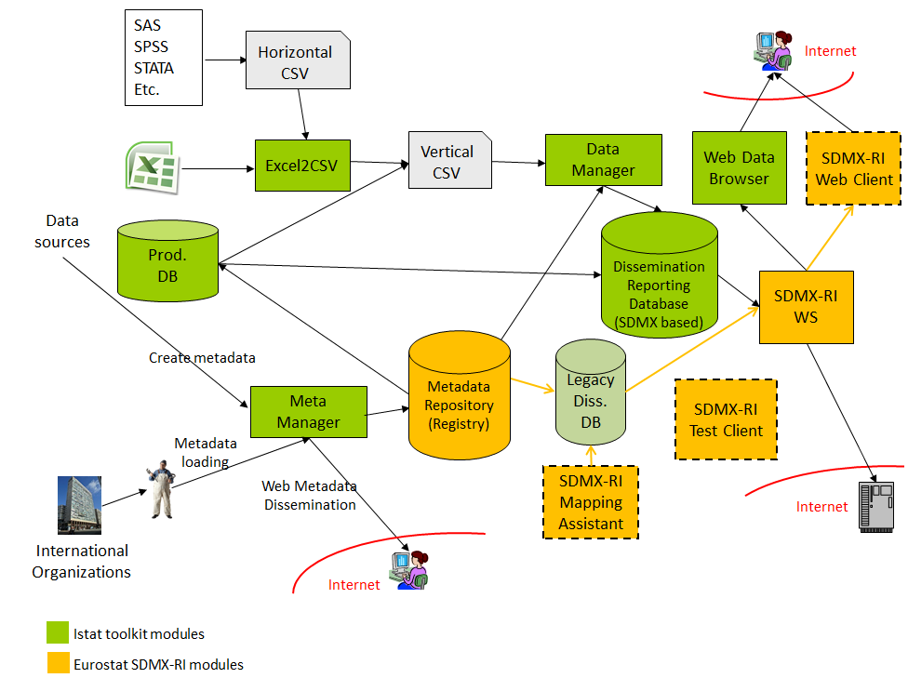

**SDMX Istat Toolkit – general characteristics**

License: EUPL

Input formats: MS Excel, CSV, SDMX-ML

Output formats: SDMX-ML, CSV, JSON, RTF data cube, DCAT[1]

Basic software required: .NET framework 4.0, Windows Server 2012[2] or sup., MS SQL Server 2012 or sup (Expression Edition is ok)

Open Source project

**SDMX Istat Toolkit building blocks**

**Metadata Web GUI[3]** – it interacts with a Metadata Repository (via the SDMX Web service) and provides a graphical user interface for browsing, download, create and submit structural metadata. The application can interact with different SDMX Web Services, therefore a user can browse metadata stored in different repositories, such as the Global registry, Eurostat registry, ECB registry, UN data, World bank, Istat, etc..

|  |  |
| --- | --- |
|  |  |

**Meta Manager** – it performs many of the functionalities[4] offered by the Metadata Web GUI, such as create *Codelists*, *Conceptscheme*, *Categoryschemes*, *Dataflows* and Data Structure Definitions. Moreover, it allows to overcome[5] some SDMX constraints, and modify “finalized” SDMX item scheme artefacts (e.g. *Codelists, Conceptschemes, Categoryschemes):*

* Add new items (delete is not allowed)
* Modify name, description, annotations, etc.
* Handle the order and hierarchy of the items
* Move a Dataflow from a Category to a another, or between different Categoryschemes

This application can also be used for building “nomenclature” servers, such as classifications’ servers and glossaries.

|  |  |
| --- | --- |
|  |  |
|  |  |

**Data Manager (former Builder and Loader)** – it creates a dissemination and reporting database (based on the SDMX Information Model). The main functionality are:

* Create a DDB scheme[6] (data cubes) from DSDs and related artefacts
* Load CVS and SDMX-ML files into the database
* Create SDMX Data Flows as sub-cubes and perform mapping actions automatically (without the support of the Mapping Assistant)
  + Sub-cubes can have less dimensions than the original cube, therefore a new data structure definition is generated automatically

This tool is optimized for working with “global DSDs” (e.g. National Accounts), allowing:

* To manage tables with different “Table identifier” attribute within the same data cube
* To upgrade DSDs automatically (e.g. from NA_MAIN+1.7+ESTAT to NA_MAIN+1.9.1+ESTAT)

|  |
| --- |
|  |

**Data Browser[7]** – It queries SDMX-RI web services and present the results in multidimensional tables and graphs. The main functionalities are:

* End-user web GUI for browsing, extracting and presenting data coming from SDMX-RI Web services (Soap and REST)
* Hub among different SDMX-RI web service
* End-user administration GUI
* localization, fonts dimensions, authentication/authorization
* Dashboards
* Themes-trees (also with virtual data flows)
* Dimensions filters management
* Pivot table
* Graphs
* Structural metadata presentation
* Links to reference metadata reports attached at data flow level

|  |  |
| --- | --- |
|  |  |

**Excel2CSV** – it is a desktop application that allows to transform a multidimensional statistical table in excel into a CSV “verticalized” file (one observation per row). It allows also to create CSV files containing code lists.

|  |
| --- |
|  |

**Metadata Repository** – it is based on the SDMX-RI Mapping Store. It allows to handle SDMX structural metadata (Data Structure Definition; Code List; Concept Scheme; Dataflow; Category Scheme; Categorisations, Hierarchical Code List; Structure Set; Process; Organisation Scheme, Provisional Agreements, Registration, Metadata Structure Definition, Metadata Flow).

**SDMX Web Service[8]** – it is based on the SDMX-RI NSI Web Service. It allows to query and submit structural metadata. Furthermore data can be extract in different formats: SDMX-ML, SDMX-JSON, SDMX-CSV and RDF data cube.

1. StatDCAT is in development
2. For presentations or small-scale implementations also windows 7 with IIS activated can be used
3. This module is not showed in the overall picture.
4. All the functionalities of the Metadata Web GUI will be implemented in the Meta Manager
5. This is achieved using a “plug-in” in the SDMX-RI web service and specific stored procedures in the Mapping Store database
6. The database scheme is a “star scheme” very similar to the OECD.STAT database scheme
7. It was built extending the Eurostat SDMX-RI Web Client tool
8. As part of the SDMX Istat Toolkit there is an extended version of the SDMX Web Service that is used by the Meta Manager in order to perform changes on “finalized” SDMX artefacts (Category schemes, Code lists, Concept schemes)